GEOSPATIAL WORLD FORUM 02 / 04 / 2019 – Taets Hemkade Amsterdam Zaandam

Welcome

Dear Exhibitor,

Welcome to A-Booth’s order form for GEOSPATIAL WORLD FORUM from 02-04-2019 until 04-04-2019, in Amsterdam.

We are pleased that Geospatial Media has asked A-Booth exhibition services to set up this order form, covering all the major points related to your participation at your exhibition. It is designed to give you the opportunity to place orders to modify and upgrade your booth to make your exhibition a real success. You are only a few steps away from a well prepared and enjoyable exhibition participation.

To be able to provide you with the best service we can offer you our early bird price until the 01-03-2019. After this date we unfortunately have to charge a surcharge of 20% on the early bird prices. Also we cannot guarantee that requested items are available for orders placed after 01-03-2019. All prices mentioned are on a rental basis, VAT excluded and, unless mentioned differently, for the full exhibition period.

We hope that you find this brochure useful and wish you every success with your exhibition preparations. Please do not hesitate to contact us if you have any questions, we are always ready to help you!

Coversheet

We kindly ask your attention for the following: if you would like to make an (additional) order for the construction, furnishing or decoration of your stand at the exhibition mentioned above, please complete this form with the requested information, choose your method of payment and send it as a coversheet along with your order forms.

If we do not receive the fully completed coversheet, the order cannot be executed.

Company Name Stand Number

Package

Contact Person

Address

Zip Code and City

Phone Number Fax Number

Email Address

Invoice Address (if aberrant)

Zip Code and City

National VAT Number

PO code

Method of payment: (after 25th of march, you can only pay with Credit card)

- Bank (after receiving an invoice/ order confirmation)

Or you can call us to provide us the credit card number. T +31 (0)75 - 6225581
Please note the 6% credit card surcharge.

- Credit card *):

- American Express

- Visa

- Eurocard/MasterCard

*) When choosing credit card as method of payment the total order amount will be raised with 6% administration fee.

Date: | Signature:

The following conditions are applicable to your order(s):
- The order coversheet must always be filled in completely and after being dated and undersigned be send to A-Booth exhibition services and/ or other selected supplier(s);
- Orders which are not accompanied by a fully completed coversheet will not be executed. This will also apply to coversheets which are not dated and/ or undersigned;
- After receiving your order A-Booth exhibition services will send a conformation. This is also an invoice for the requested services. Invoices must be fully paid BEFORE the exhibition opens. If because of the time-schedule this is not possible A-Booth exhibition services is allowed to request cash payment at the exhibition floor;
- Orders can be made at the latest at the last day available for construction and/ or decoration. For orders made at the exhibition floor during build-up an extra (transport) amount can be calculated. For these orders A-Booth exhibition services cannot guarantee that the requested colour, model, seize or number is available. Orders made at the exhibition floor will be executed at the following day, before opening of the exhibition;
- In case of payment by credit card the total order amount will be raised with 6% administration costs;
- All prices mentioned are on a rental basis, VAT of 21% excluded and, unless mentioned differently, for the full exhibition period;
- For exhibitors based outside the Netherlands no VAT will be calculated if A-Booth exhibition services is provided with their national VAT number or their Tax registration number;
- When after sending an order confirmation/ invoice the invoice address needs to be changed (including the change of the person for contact or department), a procedure needs to be started to obtain a purchase order or any other administrative number or any other essential change in the necessary invoice information has to be made an amount of € 30,00 per invoice will be charged for administration costs;
- When an order is cancelled during the period in which an early-order-discount is applicable, a percentage of 10% of the price of the items concerned is charged for administration costs;
- When an order is cancelled after the early-order-discount has come to an end, no financial restitution will be made.

Early bird prices are available till the 01-03-2019
After this date we unfortunately have to charge our regular prices (20% surcharge on the early bird prices)

ALWAYS PRESENT YOUR ORDER FORM ALONG WITH A FULLY COMPLETED COVERSHEET

Please email the completed forms to Daan@a-booth.nl
Exhibitor: |  | Stand Number:
Construction
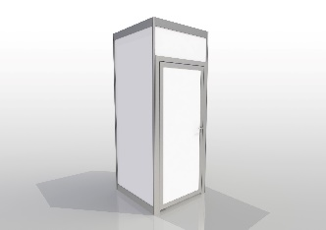 | Lockable stand storage 1x1x2.5m  Regular price € 119.05 |  | 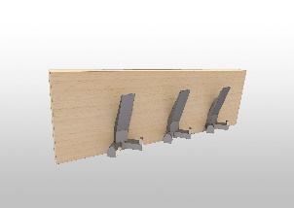 | Coat rack  Regular price € 20.99
 | Quantity: |  |  | Quantity:
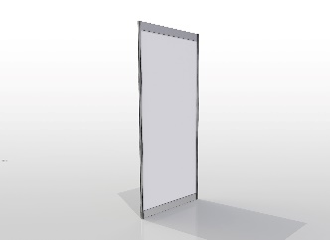 | Extra wall  Regular price € 32.83 |  | 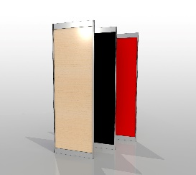 | Wall in colour Black, Red or Beech  Regular price € 44.97
 | Quantity: |  |  | Quantity:
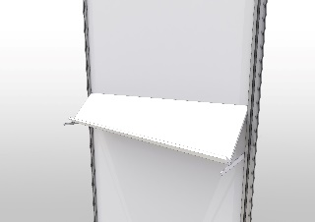 | Sloping shelf  Regular price € 28.18 |  | 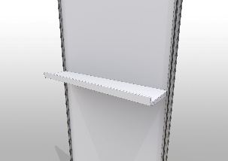 | Shelf straight  Regular price € 28.18
 | Quantity: |  |  | Quantity:
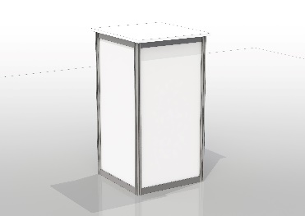 | Computer Counter 50x50x100cm high  Regular price € 102.93 |  | 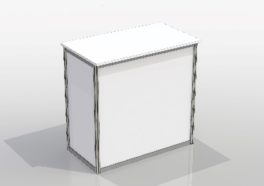 | Counter white 100x50x100cm high  Regular price € 102.93
 | Quantity: |  |  | Quantity:
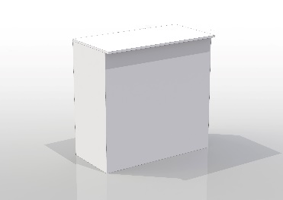 | Wooden Counter with doors 100x50x100cm high  Regular price € 159.85 |  | 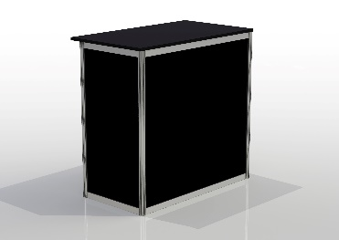 | Counter black 100x50x100cm high  Regular price € 114.43
 | Quantity: |  |  | Quantity:
Date: |  |  | Signature:

Early bird prices are available till 01-03-2019
After this date we unfortunately have to charge our regular prices (20% surcharge on the early bird prices)

ALWAYS PRESENT YOUR ORDER FORM ALONG WITH A FULLY COMPLETED COVERSHEET

Please email the completed forms to Daan@a-booth.nl

Exhibitor: |  | Stand Number:
Prints
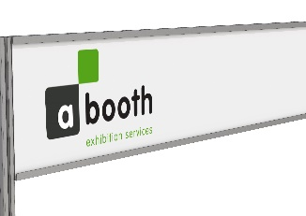 | *Full-colour logo at facia  25 cm High  Early bird price € 83.38  Price valid to max. 1 m1 |  | 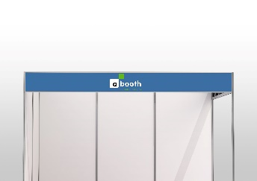 | *Full-colour printed facia panel  27 cm high  Early bird price € 54.63  Per m1
 | Quantity in m1: |  |  | Quantity in m1:
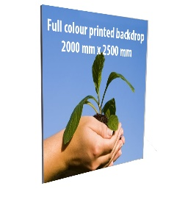 | *Full colour printed backdrop into stand  1000 mm x 2500 mm  Early bird price € 194.93  Price includes frame and fabric |  | 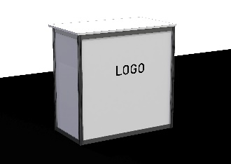 | *Full colour logo on desk  Early bird price € 109.25
 | Quantity: |  |  | Quantity:
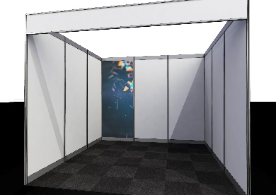 | *Full-colour printed  shell scheme wall element  1000 x 2300 mm  Early bird price € 194.93
 | Quantity:

